| **Odds Ratio Estimates and Profile-Likelihood Confidence Intervals** | | | | |  |
| --- | --- | --- | --- | --- | --- |
| **Effect** | **Unit** | **Estimate** | **95% Confidence Limits** | | **P value** |
| **age** | 5.0000 | 0.782 | 0.668 | 0.906 | 0.0015 |
| **gender Male vs Female** | 1.0000 | 2.048 | 1.202 | 3.517 | 0.0087 |
| **Nmon (ART Duration by Month)** | 1.0000 | 0.996 | 0.984 | 1.008 | 0.5168 |
| **pay Self Pay + Other vs Family Member/Spouse Pay** | 1.0000 | 0.568 | 0.286 | 1.134 | 0.1059 |
| **Prin1 (Wealth Index I)** | 0.1000 | 1.010 | 0.996 | 1.023 | 0.1583 |
| **faith_act Not Active/No Religion vs Active** | 1.0000 | 1.582 | 0.952 | 2.634 | 0.0766 |
| **family_HIV_bin none vs 1-4** | 1.0000 | 0.650 | 0.387 | 1.090 | 0.1028 |
| **treat_support Yes vs No** | 1.0000 | 1.694 | 0.870 | 3.274 | 0.1174 |
| **rhiv Who first recommended you to go to an HIV clinic? (Friend vs Family)** | 1.0000 | 0.268 | 0.102 | 0.650 | 0.0156 |
| **rhiv Who first recommended you to go to an HIV clinic? (Other vs Family)** | 1.0000 | 0.476 | 0.217 | 1.020 |
| **rhiv Who first recommended you to go to an HIV clinic? (Provider vs Family)** | 1.0000 | 0.833 | 0.455 | 1.534 |
| **arv_start Sinikithemba (Ridge House) vs Other** | 1.0000 | 0.434 | 0.189 | 1.000 | 0.0486 |
| **arv_train_bin 3+ vs 0-2** | 1.0000 | 0.430 | 0.124 | 1.404 | 0.1676 |
| **CO-TRIMOXAZOLE Yes vs No** | 1.0000 | 1.760 | 1.008 | 3.093 | 0.0474 |
| **FLUCONAZOLE Yes vs No** | 1.0000 | 5.197 | 1.469 | 24.468 | 0.0177 |
| **TBD ETHAMBUTOL Yes vs No** | 1.0000 | 3.376 | 0.905 | 14.479 | 0.0785 |

/** Model 1 =Baseline Model **/

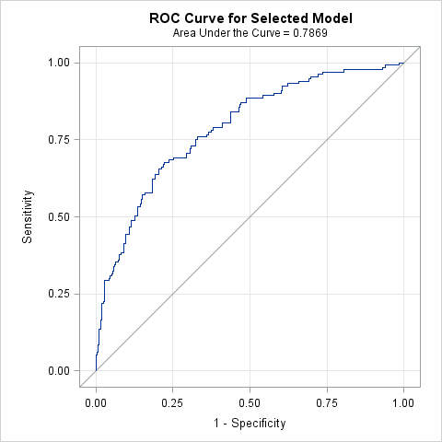

| **Hosmer and Lemeshow Goodness-of-Fit Test** | | |
| --- | --- | --- |
| **Chi-Square** | **DF** | **Pr > ChiSq** |
| 5.5698 | 8 | 0.6953 |

/** Model 2 =Demo + Socieconomic +Psycho + Symptoms + Medical History + Medications **/

/*With all suscpted variables*/

| **Odds Ratio Estimates and Profile-Likelihood Confidence Intervals** | | | | |  |
| --- | --- | --- | --- | --- | --- |
| **Effect** | **Unit** | **Estimate** | **95% Confidence Limits** | | **P value** |
| **age** | 5.0000 | 0.826 | 0.667 | 1.016 | 0.0741 |
| **gender Male vs Female** | 1.0000 | 2.665 | 1.376 | 5.268 | 0.0041 |
| **Nmon (ART by Month)** | 1.0000 | 0.999 | 0.984 | 1.014 | 0.8497 |
| **edu** | 1.0000 | 1.126 | 0.958 | 1.351 | 0.1721 |
| **pay Self Pay + Other vs Family Member/Spouse Pay** | 1.0000 | 0.512 | 0.221 | 1.184 | 0.1163 |
| **clinic_feel Pleased vs Neutral** | 1.0000 | 0.414 | 0.197 | 0.865 | 0.0189 |
| **practice_safe_bin Often,Sometimes,Rarely,Never vs Always** | 1.0000 | 5.389 | 1.889 | 15.878 | 0.0018 |
| **dep_11 12+ vs 10 or 11** | 1.0000 | 2.526 | 1.308 | 5.011 | 0.0066 |
| **faith_act Not Active/No Religion vs Active** | 1.0000 | 2.157 | 1.144 | 4.140 | 0.0187 |
| **family_HIV_bin none vs 1-4** | 1.0000 | 0.630 | 0.331 | 1.189 | 0.1555 |
| **symptom_fatigue Patient have symptom=Yes vs No** | 1.0000 | 2.782 | 1.430 | 5.503 | 0.0028 |
| **symptom_sex Patient have symptom=Yes vs No** | 1.0000 | 1.669 | 0.843 | 3.283 | 0.1381 |
| **symptom_diarr Patient have symptom=Yes vs No** | 1.0000 | 2.797 | 1.095 | 7.160 | 0.0307 |
| **log_cd4** | 1.0000 | 0.074 | 0.022 | 0.222 | <.0001 |
| **aids_condition___6(Cryptococcus) Yes vs No** | 1.0000 | 0.042 | 0.001 | 0.518 | 0.0245 |
| **non_aids_condition5(Lipodystrophy) Yes vs No** | 1.0000 | 0.314 | 0.139 | 0.668 | 0.0037 |
| **ses_num 2-4 vs 0-1** | 1.0000 | 0.270 | 0.094 | 0.750 | 0.0438 |
| **ses_num 5+ vs 0-1** | 1.0000 | 0.334 | 0.096 | 1.124 |
| **CO-TRIMOXAZOLE Yes vs No** | 1.0000 | 0.554 | 0.257 | 1.183 | 0.1289 |
| **FLUCONAZOLE Yes vs No** | 1.0000 | 12.906 | 1.314 | 333.461 | 0.0534 |
| **TBD ETHAMBUTOL Yes vs No** | 1.0000 | 2.366 | 0.433 | 13.364 | 0.3200 |
| **remember_meds___7(TV/Radio) Yes vs No** | 1.0000 | 2.802 | 0.960 | 8.130 | 0.0566 |
| **rhiv Who first recommended you to go to an HIV clinic? (Friend vs Family)** | 1.0000 | 0.207 | 0.065 | 0.597 | 0.0175 |
| **rhiv Who first recommended you to go to an HIV clinic? (Other vs Family)** | 1.0000 | 0.326 | 0.118 | 0.854 |
| **rhiv Who first recommended you to go to an HIV clinic? (Provider vs Family)** | 1.0000 | 0.603 | 0.281 | 1.294 |
| **arv_start Sinikithemba (Ridge House) vs Other** | 1.0000 | 0.368 | 0.144 | 0.939 | 0.0361 |

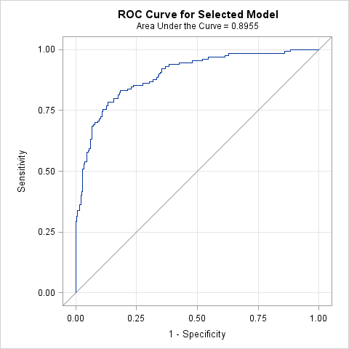

| **Hosmer and Lemeshow Goodness-of-Fit Test** | | |
| --- | --- | --- |
| **Chi-Square** | **DF** | **Pr > ChiSq** |
| 16.0217 | 8 | 0.0421 |

/** Model 3 =Demo + Socieconomic +Psycho + Accesss **/

| **Odds Ratio Estimates and Profile-Likelihood Confidence Intervals** | | | | |  |
| --- | --- | --- | --- | --- | --- |
| **Effect** | **Unit** | **Estimate** | **95% Confidence Limits** | | **P value** |
| **age** | 5.0000 | 0.837 | 0.701 | 0.996 | 0.0474 |
| **gender Male vs Female** | 1.0000 | 2.412 | 1.410 | 4.173 | 0.0014 |
| **Nmon (ART by Month)** | 1.0000 | 0.988 | 0.976 | 0.999 | 0.0310 |
| **Mpr (Access)** | 0.1000 | 0.940 | 0.765 | 1.139 | 0.5383 |
| **edu** | 1.0000 | 1.103 | 0.966 | 1.279 | 0.1669 |
| **pay Self Pay + Other vs Family Member/Spouse Pay** | 1.0000 | 0.530 | 0.269 | 1.047 | 0.0663 |
| **Prin1 (Wealth Index I)** | 0.1000 | 1.014 | 1.000 | 1.028 | 0.0544 |
| **clinic_feel Pleased vs Neutral** | 1.0000 | 0.371 | 0.205 | 0.666 | 0.0009 |
| **practice_safe_bin Often,Sometimes,Rarely,Never vs Always** | 1.0000 | 3.140 | 1.406 | 7.214 | 0.0058 |
| **dep_11(Depression Score) 12+ vs 10 or 11** | 1.0000 | 2.850 | 1.695 | 4.884 | 0.0001 |
| **faith_act Not Active/No Religion vs Active** | 1.0000 | 1.419 | 0.844 | 2.389 | 0.1858 |
| **treat_support Yes vs No** | 1.0000 | 1.697 | 0.883 | 3.254 | 0.1106 |
| **family_HIV_bin none vs 1-4** | 1.0000 | 0.731 | 0.439 | 1.218 | 0.2282 |
| **knows_hiv Yes vs No** | 1.0000 | 0.411 | 0.089 | 2.186 | 0.2594 |

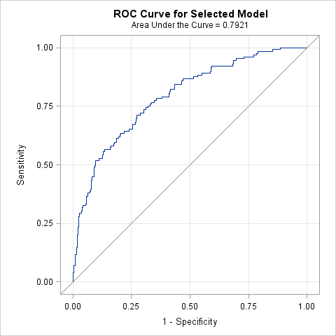

| **Hosmer and Lemeshow Goodness-of-Fit Test** | | |
| --- | --- | --- |
| **Chi-Square** | **DF** | **Pr > ChiSq** |
| 3.9776 | 8 | 0.8591 |

/** Model 4 =Demo + Psycho + Symptoms + Medical History + Medications + Adherence **/

| **Odds Ratio Estimates and Profile-Likelihood Confidence Intervals** | | | | |  |
| --- | --- | --- | --- | --- | --- |
| **Effect** | **Unit** | **Estimate** | **95% Confidence Limits** | | **P value** |
| **age** | 5.0000 | 0.768 | 0.628 | 0.926 | 0.0075 |
| **gender Male vs Female** | 1.0000 | 2.457 | 1.206 | 5.108 | 0.0142 |
| **Nmon (ART by Month)** | 1.0000 | 1.008 | 0.992 | 1.024 | 0.3294 |
| **Pill(Adherence)** | 0.1000 | 0.563 | 0.404 | 0.772 | 0.0005 |
| **clinic_feel Pleased vs Neutral** | 1.0000 | 0.443 | 0.203 | 0.959 | 0.0387 |
| **practice_safe_bin Often,Sometimes,Rarely,Never vs Always** | 1.0000 | 5.521 | 1.678 | 18.806 | 0.0053 |
| **dep_11(Depression Score) 12+ vs 10 or 11** | 1.0000 | 3.035 | 1.509 | 6.340 | 0.0023 |
| **faith_act Not Active/No Religion vs Active** | 1.0000 | 1.987 | 1.022 | 3.926 | 0.0446 |
| **treat_support Yes vs No** | 1.0000 | 1.831 | 0.741 | 4.437 | 0.1826 |
| **family_HIV_bin none vs 1-4** | 1.0000 | 0.496 | 0.250 | 0.968 | 0.0415 |
| **symptom_fatigue Patient have symptom=Yes vs No** | 1.0000 | 2.625 | 1.304 | 5.365 | 0.0072 |
| **symptom_diarr Patient have symptom=Yes vs No** | 1.0000 | 1.912 | 0.682 | 5.251 | 0.2102 |
| **symptom_skin Patient have symptom=Yes vs No** | 1.0000 | 1.646 | 0.813 | 3.331 | 0.1643 |
| **symptom_sex Patient have symptom=Yes vs No** | 1.0000 | 1.754 | 0.836 | 3.656 | 0.1342 |
| **log_cd4** | 1.0000 | 0.077 | 0.024 | 0.222 | <.0001 |
| **aids_condition___6(Cryptococcus) Yes vs No** | 1.0000 | 0.019 | <0.001 | 0.371 | 0.0220 |
| **non_aids_condition5(Lipodystrophy) Yes vs No** | 1.0000 | 0.485 | 0.210 | 1.066 | 0.0797 |
| **arv_start Sinikithemba (Ridge House) vs Other** | 1.0000 | 0.442 | 0.151 | 1.319 | 0.1367 |
| **rhiv Who first recommended you to go to an HIV clinic? (Friend vs Family)** | 1.0000 | 0.201 | 0.057 | 0.624 | 0.0184 |
| **rhiv Who first recommended you to go to an HIV clinic? (Other vs Family)** | 1.0000 | 0.287 | 0.099 | 0.778 |
| **rhiv Who first recommended you to go to an HIV clinic? (Provider vs Family)** | 1.0000 | 0.630 | 0.277 | 1.428 |
| **ses_num 2-4 vs 0-1** | 1.0000 | 0.348 | 0.097 | 1.197 | 0.2442 |
| **ses_num 5+ vs 0-1** | 1.0000 | 0.419 | 0.097 | 1.742 |
| **remember_meds___2(Clock/Watch) Yes vs No** | 1.0000 | 0.418 | 0.133 | 1.218 | 0.1201 |
| **remember_meds___7(TV/Radio) Yes vs No** | 1.0000 | 3.677 | 1.168 | 11.719 | 0.0256 |
| **FLUCONAZOLE Yes vs No** | 1.0000 | 36.080 | 2.507 | >999.999 | 0.0119 |

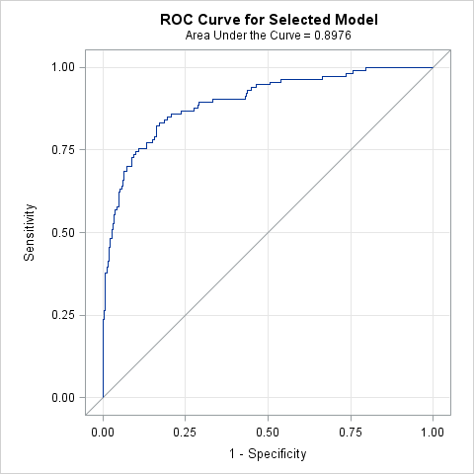

| **Hosmer and Lemeshow Goodness-of-Fit Test** | | |
| --- | --- | --- |
| **Chi-Square** | **DF** | **Pr > ChiSq** |
| 8.6197 | 8 | 0.3754 |

/** Model 5 =Demo + Socieconomic +Psycho + Symptoms + Medical History + Medications + Access + Adherence **/

/*With single-out from domain*/

| **Odds Ratio Estimates and Profile-Likelihood Confidence Intervals** | | | | |  |
| --- | --- | --- | --- | --- | --- |
| **Effect** | **Unit** | **Estimate** | **95% Confidence Limits** | | **P value** |
| **age** | 5.0000 | 0.783 | 0.638 | 0.950 | 0.0158 |
| **gender Male vs Female** | 1.0000 | 2.574 | 1.254 | 5.404 | 0.0108 |
| **Nmon (ART)** | 1.0000 | 1.008 | 0.992 | 1.025 | 0.3100 |
| **Pill (Adherence)** | 0.1000 | 0.561 | 0.402 | 0.770 | 0.0005 |
| **pay Self Pay + Other vs Family Member/Spouse Pay** | 1.0000 | 0.629 | 0.262 | 1.532 | 0.3008 |
| **clinic_feel Pleased vs Neutral** | 1.0000 | 0.453 | 0.207 | 0.982 | 0.0449 |
| **practice_safe_bin Often,Sometimes,Rarely,Never vs Always** | 1.0000 | 5.644 | 1.719 | 19.178 | 0.0046 |
| **dep_11 (Depression Score) 12+ vs 10 or 11** | 1.0000 | 2.909 | 1.436 | 6.110 | 0.0037 |
| **faith_act Not Active/No Religion vs Active** | 1.0000 | 2.164 | 1.090 | 4.384 | 0.0289 |
| **treat_support Yes vs No** | 1.0000 | 1.722 | 0.689 | 4.221 | 0.2370 |
| **family_HIV_bin none vs 1-4** | 1.0000 | 0.503 | 0.253 | 0.982 | 0.0460 |
| **symptom_fatigue Patient have symptom=Yes vs No** | 1.0000 | 2.528 | 1.250 | 5.184 | 0.0103 |
| **symptom_diarr Patient have symptom=Yes vs No** | 1.0000 | 1.926 | 0.684 | 5.328 | 0.2077 |
| **symptom_skin Patient have symptom=Yes vs No** | 1.0000 | 1.649 | 0.812 | 3.346 | 0.1643 |
| **symptom_sex Patient have symptom=Yes vs No** | 1.0000 | 1.800 | 0.858 | 3.750 | 0.1169 |
| **log_cd4** | 1.0000 | 0.074 | 0.023 | 0.216 | <.0001 |
| **aids_condition___6(Cryptococcus) Yes vs No** | 1.0000 | 0.019 | <0.001 | 0.357 | 0.0211 |
| **non_aids_condition5(Lipodystrophy) Yes vs No** | 1.0000 | 0.470 | 0.201 | 1.036 | 0.0690 |
| **arv_start Sinikithemba (Ridge House) vs Other** | 1.0000 | 0.459 | 0.157 | 1.372 | 0.1562 |
| **rhiv Who first recommended you to go to an HIV clinic? (Friend vs Family)** | 1.0000 | 0.216 | 0.061 | 0.678 | 0.0272 |
| **rhiv Who first recommended you to go to an HIV clinic? (Other vs Family)** | 1.0000 | 0.313 | 0.107 | 0.862 |
| **rhiv Who first recommended you to go to an HIV clinic? (Provider vs Family)** | 1.0000 | 0.693 | 0.299 | 1.613 |
| **ses_num 2-4 vs 0-1** | 1.0000 | 0.328 | 0.091 | 1.133 | 0.2116 |
| **ses_num 5+ vs 0-1** | 1.0000 | 0.392 | 0.090 | 1.640 |
| **remember_meds___2(Clock/Watch) Yes vs No** | 1.0000 | 0.417 | 0.133 | 1.211 | 0.1179 |
| **remember_meds___7(TV/Radio) Yes vs No** | 1.0000 | 3.744 | 1.181 | 12.096 | 0.0248 |
| **FLUCONAZOLE Yes vs No** | 1.0000 | 35.049 | 2.484 | 967.515 | 0.0122 |

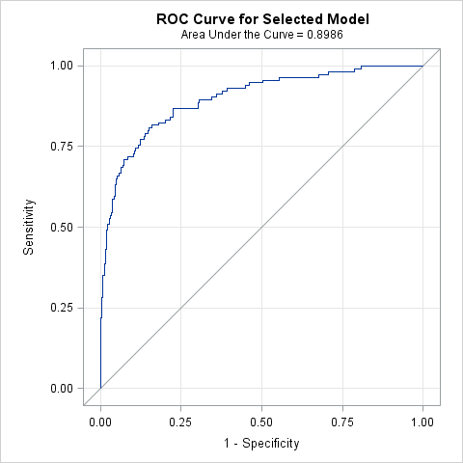

| **Hosmer and Lemeshow Goodness-of-Fit Test** | | |
| --- | --- | --- |
| **Chi-Square** | **DF** | **Pr > ChiSq** |
| 3.1714 | 8 | 0.9231 |